

**Travel Planner**

**Senior By**

**Rabih Sharaf Al dein & Ghaith Abou El Ezz**

**Lebanese International University**

**Bekaa Campus, Lebanon**

**School of Arts and Science**

**BACHERLOR OF SCIENCE IN**

**COMPUTER SCIENCE AND INFORMATION TECHNOLOGY**

**Supervised by: Dr. Walid Amer**

**Fall 2025 – 2026**

**Table of Contents**

**Chapter 1: Introduction**

Introduction to the Travel Planner System …………………1.1  
The Problem ………………………………………………...1.2  
The Solution ………………………………………………….1.3  
Objectives ……………………………………………………1.4  
Scope …………………………………………………………1.5  
System Inclusions     ……………………………………….1.5.1  
System Exclusions     ………………………………………1.5.2  
Technology Requirements …………………………………1.6  
Software Requirements  ……………………………………1.6.1  
Hardware Requirements  …………………………………1.6.2  
System Structure ………………………………………………………17

**Chapter 2: System Requirements and Analysis**

Functional Requirements ……………………………………2.1  
User Profile    ……………………………………………………… 2.1.1  
Accommodation Management   …………………………………… . …….2.1.2  
Destination Listing     ……………………………………2.1.3  
    Events Listing ………………………………………..2.1.4  
 Flight Search    ……………………………………………2.1.5

Non-Functional Requirements………………………………2.2  
Security Requirements     …………………………………2.2.1  
 Usability Requirements    ………………………………..2.2.2  
Maintainability Requirements  ……………………………………………...2.2.3  
Scalability Requirements  ………………………………… 2.2.4  
Data Integrity Requirements   …………………………… 2.2.5

UML Use Case Diagram and Specifications ………………………………………………...2.3  
Use Case Diagram     ………………………………………2.3.1  
Use Case Specifications    ………………………………… 2.3.2  
        • Register User  
        • Login User  
        • Plan Trip  
        • Book Flights  
        • Reserve Accommodations  
        • Set Budget  
        • Write Review  
        • Manage Users  
        • Process Payments  
        • Apply Discounts  
        • Arrange Transportation  
        • Book Activities

**Chapter 3: Database Design**

ERD Diagram Overview ……………………………………..3.1  
Database Tables Description ………………………………3.2  
Users………………………………………………………..3.2.1  
Flights………………………………………………………3.2.2  
Destinations………………………………………………3.2.3  
Accommodations………………………………………….3.2.4  
Events ……………………………………………………..3.2.5  
Trips ……………………………………………………… 3.2.6  
Bundle Trips ……………………………………………….3.2.7  
Reviews…………………………………………………….3.2.9

Many-to-Many Relationship Tables………………………….3.3

**Chapter 4: System Implementation**

Introduction………………………………………………….4.1  
Project Parts………………………………………………….4.2  
Register Page……………………………………………… 4.2.1  
Login Page………………………………………………. 4.2.2  
Home Page………………………………………………..4.2.3  
Destinations Page…………………………………………4.2.4  
Accommodation Page……………………………………. 4.2.5  
Transport Page…………………………………………….4.2.6  
Events Page………………………………………………..4.2.7  
Bundle Trips Page………………………………………….4.2.8  
Writea Review Page………………………………………. 4.2.9  
Profile Page………………………………………………..4.2.10  
Destination Details Page…………………………………..4.2.11  
Bundle Trip Details Page………………………………… 4.2.12  
Trip Details Card Page…………………………………….4.2.13  
Wishlist Page……………………………………………4.2.14  
Update Password Pag…………………………………..4.2.15  
Chat Bot Page…………………………………………..4.2.16  
Admin Page…………………………………………….4.2.17

Conclusion……………………………………………………5

Future Work…………………………………………………..6

## Chapter 1:Introduction to the Travel Planner System

##### Introduction

Planning travels today can be complicated and time consuming . Travelers often need to visit many different websites to book flights, find hotels, and discover activities. This scattered approach makes trip planning stressful and inefficient.

The Travel Planner platform solves this problem by bringing everything together in one place. It allows users to plan, book, manage their entire trip through a single system. By combining destinations, accommodations, transportation, and activities in one platform, we make travel planning simpler and more organized .

#### 1.2 The Problem

**Current travel planning methods face several important challenges:**

**Too Many Sources:** Travelers must use multiple websites and apps for different parts of their trip, which can be confusing and time consuming.

**Hard to Coordinate:** Booking flights, hotels, and activities separately makes it difficult to ensure everything works together smoothly.

**Missed Savings:** Without package options, travelers often pay more by booking everything separately.

**Limited Options**: Most systems offer either completely fixed packages or require too much work to build custom trips.

#### 1.3 The Solution

**The Travel Planner system offers two main ways to plan trips:**

**Custom Trips:** Users can build their own trips by choosing individual destinations,hotels,transportation, and activities.The system automatically calculates costs and checks availability.

**Ready-Made Packages:** we offer complete travel packages that include multiple destinations,hotels,transportation, and activities. These packages are organized by day and often cost less than booking everything separately.

The system uses a single database to ensure all information is current and all bookings work together properly.

#### Objectives

**Our main goals for the Travel Planner are:**

1. **Easy to Use :** Create a simple interface that guides users through the planning process
2. **All in one platform:** Combine all travel services in one place with real time availability
3. **Flexible options:** Support both custom trips and premade packages
4. **Reliable performance:** Build a system that works well as more people use it
5. **Cost effective**: Offer competitive pricing and bundle discounts
6. **Smart suggestions:** Provide personalized recommendations based on user preferences

##### Scope

**What the System includes:**

* User accounts and profiles
* Destinations information and search
* Hotel search and booking
* Transportation options and booking
* Activity and event booking
* Custom trip builder
* Package trips
* Payment processing
* Review system
* Admin management tools

**What the System does not include:**

* Visa applications
* Travel insurance
* Real time flight tracking
* Currency exchange
* Physical ticket delivery
* Local concierge services

##### Technology Requirements

**Software Needed:**

1. **Frontend:** HTML, CSS, JavaScript
2. **Backend**: PHP
3. **Database:** MySQL
4. **Server**: Apache
5. **DE/Code Editor:** VS Code

**Hardware Needed:**

1. Laptop

#### System Structure:

**The Travel Planner uses a three layer design:**

User Interface: Website that users interact with

Application Logic: PHP programs that process user requests

Database:MySQL system that stores all info

The database is organized with multiple connected tables to ensure information stays consistent and searches work quickly.

Chapter 2**:** This chapter contains the functional and non functional requirements. Also it contain the UseCase Diagram and its specifications**.**

**2.1: Functional requirements:**

* **User Profile**
* The system shall allow users to view their profile information.
* The system shall allow users to update their personal details (name, last name, email).
* The system shall generate a unique username automatically during registration.
* **Accommodation Management**
* **Admin:**
  + The system shall allow the admin to add new accommodations.
  + The system shall allow the admin to edit existing accommodations.
  + The system shall allow the admin to delete accommodations.
* **User:**
  + The system shall display all available accommodations to users.
  + The system shall allow users to filter accommodations by:
    - Rating, Price and Type.
* The system shall allow users to search accommodations by name or keyword.
* The system shall allow users to view full accommodation details.
* **Destination Listing**
* The system shall display a list of available travel destinations on the Destinations page.
* The system shall retrieve all destination data from the database using PHP.
* The system shall display each destination with the following details:
  + Destination name, location, description, image.
* **Events Listing**
  + The system shall display a list of upcoming events on the Events page.
  + The system shall retrieve event data from the database using PHP.
  + Each event displayed shall include: event name, date and time, location, description, event type.
* **Flight Search**
  + The system shall allow users to search for flights using the following fields: Departure location, Arrival location, departure date, return date, number of travelers, class.
  + The system shall validate user input before processing the search.
  + The system shall retrieve available flights from the database or external data source.

**2.2 Non-Functional Requirements:**

* **Security Requirements**
* User passwords shall be encrypted using bcrypt hashing before storage.
* The system shall prevent SQL Injection by using **prepared statements** for all database operations
* Only admin accounts shall access restricted admin pages (role-based access control).
* Sensitive user data (email, bookings) shall only be accessible when logged in.
* **Usability Requirements**
* The UI shall be clear, intuitive, and follow consistent design across all pages.
* Error messages shall be human-readable and guide the user on how to fix issues.
* Navigation menus shall be easy to use and accessible across all pages.
* **Maintainability Requirements**
  + The codebase shall be modular, using separate files for: PHP backend, Javascript, HTML, CSS styling, Database configuration.
  + The system shall follow standard naming conventions for variables, files, and functions.
  + Developers shall be able to update modules (Flights, Events, Accommodations, etc.) independently.
  + Comments and documentation shall be provided for complex functions.
* **Scalability Requirements**
  + The system architecture shall allow future expansion such as: adding new travel modules (events, car rentals, guides).
  + The database structure shall support growth in the number of users, destinations, events, and flights.
  + The system shall allow caching and performance optimization as traffic increases.
* **Data Integrity Requirements**
  + The system shall ensure that all user data is stored accurately and consistently.
  + Duplicate account creation using the same email shall be prevented.
  + Booking records shall always reflect correct prices and dates.
  + Data changes shall be validated before updates (admin edits, user profile changes).

**2.3 UML UseCase Diagram and Specifications**

**2.3.1 – UseCase Diagram:**

**Main Actors:**

1. **User :** A registered user can book a complete trip and can give a rating and a review.
2. **Admin:** An admin can add ready made bundle trips and can add any new flights, destinations, events, transports and accommodations, and he can view the trip details, view booking history and manage inappropriate reviews.

**UseCase by Actor:**

* **Admin UseCase:**
  1. Login into the system
  2. Add new trip.
  3. Delete trip.
  4. Add and delete ready-made bundle trip.
  5. Add and delete accommodations.
  6. Add and delete flights.
  7. View booking history.
  8. Manage inappropriate reviews.
* **User UseCase:**
  + - 1. Register on the system.
      2. Login to the system.
      3. Reset Password
      4. Update Profile
      5. Plan Trip
         1. **Extends**: Delete trip, Edit trip and View trip details
         2. **Includes**: Add destination and Manage trip components.
      6. Book flight
         1. **Includes**: Confirm booking.
         2. **Extends**: Edit booking, Cancel booking and View booking history.
      7. Reserve Accommodation
         1. **Includes**: Confirm booking.
         2. **Extends**: Edit booking, Cancel booking and View booking history.
      8. Book Activities
         1. **Includes**: Confirm booking.
         2. **Extends**: Edit booking, Cancel booking and View booking history.
      9. Arrange Transportation
         1. **Includes**: Confirm booking.
         2. **Extends**: Edit booking, Cancel booking and View booking history.
      10. Set Budget
      11. Track Expenses
      12. Process Payment
          1. **Include:** Manage payment method and Generate financial report
          2. **Extends:** Apply discount
      13. Write Reviews
          1. **Extends:** Delete review, Rate destinations, accommodationsand events.
      14. Read Reviews.

### UseCase Diagram:

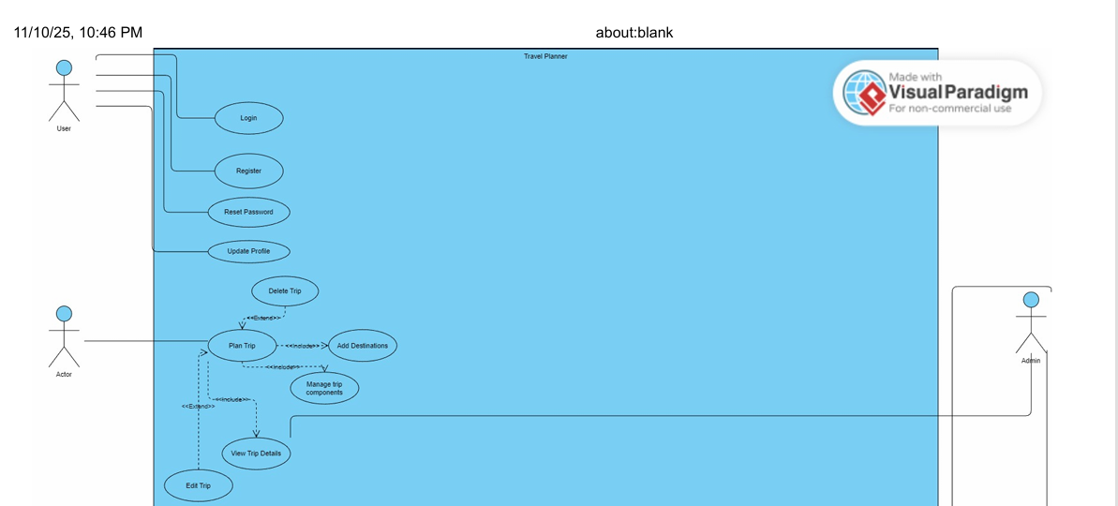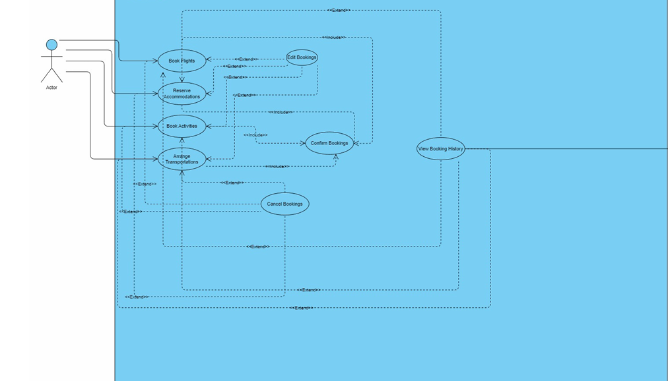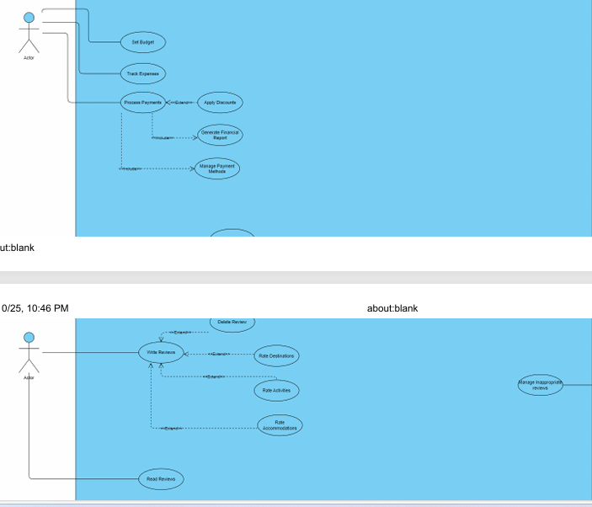

**2.3.2 – UseCase Specification:**

This section presents the narrative descriptions of the main use cases for the Travel Planner System. Each description outlines how users interact with the system to perform key tasks such as registering, logging in, searching for destinations, viewing accommodations, booking events, and managing travel plans. The narratives specify the actors involved, the goals of each interaction, and the typical sequence of steps taken by the system and the user. These descriptions help define the functional behavior of the system and ensure clarity in how the system should respond to user actions.

**Narrative 1: User Register**

|  |
| --- |
| **Use Case Name:** Register User |
| **Actors:** User (primary) |
| **Description:** Allows a new user to create an account in the Travel Planner system by providing required personal information and credentials. |
| **Basic Flow:**   1. User selects “Register” option 2. System displays registration form 3. User enters: name, email, username, password, confirm password 4. System validates all fields 5. System checks email/username uniqueness 6. System creates new user account 7. System sends confirmation email 8. System displays success message 9. System redirects to login page |
| **Alternative Flow:**   * Validation Errors:  1. if any field fails validation, system displays specific error messages 2. User corrects errors and resubmits 3. Resume at step 4  * Email/Username Already Exists:  1. If email or username already exists, system displays error message 2. User provides different email/username or selects “Forgot Password” 3. Resume at step 3 |
| **Preconditions:**   * User is not logged into the system * User has not previously registered with the same email/username |
| **Postconditions:**   * New user account is created in database * User can now log into the system * Confirmation email is sent to user’s email |

**Narrative 2: User Login**

|  |
| --- |
| **Use Case Name:** Login User |
| **Actors:** User, Admin |
| **Description:** Allows users and administrators to authenticate and access the Travel Planner system using their credentials |
| **Basic Flow:**   1. Actor navigates to login page 2. System displays login form with username/email and password fields 3. Actor enters credentials 4. System validates credentials against database 5. System checks user role and permissions 6. System creates appropriate session based on role 7. System logs login activity for security monitoring 8. System redirects to appropriate dashboard: User->Personal trip dashboard , Admin->Admin management panel |
| **Alternative Flow:**   * Invalid Credentials:  1. If credentials are invalid, system displays generic error message 2. Actor can re-enter credentials or select “Forgot Password” 3. Resume at step 3 |
| **Preconditions:**   * Actor has a registered account in the system * Actor is not currently logged in |
| **Postconditions:**   * Actor is authenticated and logged into system * Appropriate session is established base on user role * Actor can access role specific features and data * Login activity is recorded in security logs |

**Narrative 3: Plan Trip**

|  |
| --- |
| **Use Case Name:** Plan Trip |
| **Actors:** User |
| **Description:** Allows users to create a new trip with basic details, dates, and initial setup that serves as the foundation for trip planning. |
| **Basic Flow:**   1. User selects "Create New Trip" from dashboard 2. System displays trip creation form with required fields 3. User enters: trip name, description, start date, end date, budget range, traveler count 4. System validates all entered data 5. System creates new trip record in database 6. System associates trip with user account 7. System generates initial trip ID and structure 8. System redirects to trip planning dashboard 9. System displays success confirmation |
| **Alternative Flow:**   * Invalid Date Range :  1. If end date is before start date, system displays date validation error 2. User corrects date range and resubmits 3. Resume at step 4  * Missing Required Fields:  1. If required fields are empty, system highlights missing fields 2. User completes required information and resubmits 3. Resume at step 4 |
| **Preconditions:**   * User is logged into the system * User has necessary trip information ready (dates, destination ideas) |
| **Postconditions:**   * New trip record created in database * Trip is associated with user account * User can now add destinations, accommodations, and activities * Trip appears in user's trip list |

**Narrative 4: Book Flights**

|  |
| --- |
| **Use Case Name:** Book Flights |
| **Actors:** User |
| **Description:**Allows users to search, compare, and book flight tickets for their planned trips. |
| **Basic Flow:**   1. User selects trip and navigates to flights section 2. System displays flight search form 3. User enters: departure city, destination, dates, passenger count, class 4. System searches available flights from integrated APIs 5. System displays flight options with prices and details 6. User selects preferred flight 7. System shows flight details and total cost 8. User confirms booking 9. System processes payment 10. System generates booking confirmation and e-ticket 11. System sends confirmation email 12. System updates trip with flight information |
| **Alternative Flow:**   * No Flights Available:  1. If no flights match criteria, system suggests alternative dates/routes 2. User modifies search criteria or selects alternative 3. Resume at step 4  * Payment Failure:  1. If payment fails, system displays error and suggests alternative payment 2. User updates payment method or tries again 3. Resume at step 8 |
| **Preconditions:**   * User is logged in * User has at least one created trip * User has sufficient payment method set up |
| **Postconditions:**   * Flight booking confirmed with airline * Payment processed successfully * E-ticket generated and stored * Trip updated with flight details * Booking confirmation sent to user |

**Narrative 5: Reserve Accommodations**

|  |
| --- |
| **Use Case Name:** Reserve Accommodations |
| **Actors:** User |
| **Description:**Allows users to search, compare, and book hotel accommodations for their trips. |
| **Basic Flow:**   1. User selects trip and navigates to accommodations section 2. System displays hotel search form 3. User enters: destination, check-in/check-out dates, rooms, guests 4. System searches available hotels from partner APIs 5. System displays hotel options with prices, ratings, and amenities 6. User selects preferred hotel and room type 7. System shows detailed hotel information and total cost 8. User confirms reservation 9. System processes payment for deposit/full amount 10. System generates booking confirmation 11. System sends confirmation email with reservation details 12. System updates trip with accommodation information |
| **Alternative Flow:**   * No Availability:  1. If no hotels available for selected dates, system suggests alternatives 2. User modifies dates or search criteria 3. Resume at step 4 |
| **Preconditions:**   * User is logged in * User has an active trip with destination and dates set * User has payment method configured |
| **Postconditions:**   * Hotel reservation confirmed * Payment processed * Reservation details stored in system * Trip updated with accommodation information * Confirmation sent to user |

**Narrative 6: Set Budget**

|  |
| --- |
| **Use Case Name:** Set Budget |
| **Actors:** User |
| **Description:** Allows users to define and manage spending limits for their trips across different categories. |
| **Basic Flow:**   1. User selects trip and navigates to budget section 2. System displays budget setup interface with categories 3. User sets overall trip budget 4. User allocates amounts to categories: flights, accommodations, activities, food, transportation, misc 5. System validates allocations don't exceed total budget 6. User confirms budget settings 7. System saves budget plan 8. System displays budget overview with allocations 9. System sets up expense tracking for the trip |
| **Alternative Flow:**   * Exceed Total Budget:  1. If category allocations exceed total budget, system shows warning 2. Resume at step 5 |
| **Preconditions:**   * User is logged in * User has at least one created trip * User understands their financial constraints |
| **Postconditions:**   * Budget plan created and saved * Expense tracking activated for trip * Budget alerts and monitoring set up * User can track spending against budget |

**Narrative 7: Write Review**

|  |
| --- |
| **Use Case Name:** Write Review |
| **Actors:** User |
| **Description:** Allows users to create and submit reviews for destinations, accommodations, activities, or services they have experienced. |
| **Basic Flow:**   1. User navigates to reviews section or selects item from trip history 2. System displays review creation form 3. User selects rating (1-5 stars) 4. User writes review text 5. User can optionally upload photos 6. System validates review content 7. User submits review 8. System saves review with pending status 9. System conducts automated content screening 10. System publishes review (if passes screening) 11. System updates item's average rating 12. System confirms review publication |
| **Alternative Flow:**   * Content Violation:  1. If review fails automated screening, flagged for manual review 2. Admin reviews and approves/rejects 3. User notified of status |
| **Preconditions:**   * User is logged in * User has completed a trip that included the item being reviewed * User has actual experience with the reviewed item |
| **Postconditions:**   * Review published and visible to other users * Item's average rating updated * User's review history updated * Review contributes to community knowledge |

**Narrative 8: Manage Users**

|  |
| --- |
| **Use Case Name:** Manage Users |
| **Actors:** Admin |
| **Description:** Allows administrators to manage user accounts, including viewing, modifying, and maintaining user records and permissions. |
| **Basic Flow:**   1. Admin navigates to user management section 2. System displays user list with search and filter options 3. Admin searches for specific user or views user list 4. System displays user details and account information 5. Admin selects action: view, edit, disable, or delete user 6. For edit: Admin modifies user information and saves changes 7. For disable: Admin disables account with reason 8. For delete: Admin confirms permanent deletion 9. System processes the requested action 10. System logs the administrative action 11. System confirms completion to admin 12. If account modified, system notifies user of changes |
| **Alternative Flow:**   * Bulk Actions:  1. Admin selects multiple users for bulk action 2. System confirms bulk operation 3. System processes all selected users 4. Resume at step 10  * User Has Active Bookings:  1. If user has active bookings, system prevents deletion 2. Admin can disable account instead of deleting |
| **Preconditions:**   * Admin is logged into admin panel * Admin has appropriate permissions for user management * User management module is accessible |
| **Postconditions:**   * User account updated as requested * Administrative action logged for audit * User notified if account status changed * System integrity maintained * Compliance with data protection regulations |

**Narrative 9: Process Payments**

|  |
| --- |
| **Use Case Name:** Process Payments |
| **Actors:** User (primary) |
| **Description:** Handles secure payment processing for various transactions including bookings, upgrades, and service fees. |
| **Basic Flow:**   1. User proceeds to checkout for booking/purchase 2. System displays order summary with total amount 3. User selects payment method (card, PayPal, etc.) 4. If new card, user enters card details securely. 5. System validates payment information 6. System sends payment request to payment gateway 7. Payment gateway processes transaction 8. System receives payment confirmation 9. System updates booking status to confirmed |
| **Alternative Flow:**   * Payment Declined:  1. If payment declined, system displays decline reason 2. User can try different payment method or contact bank 3. Resume at step 3  * Partial Payment:  1. For high-value items, user can select deposit option 2. System processes partial payment 3. Balance due date set and reminders scheduled |
| **Preconditions:**   * User is logged in * User has items in cart or pending booking * User has payment method on file or ready to enter * Transaction amount is calculated |
| **Postconditions:**   * Payment successfully processed * Booking confirmed and activated * Receipt generated and stored * User notified of successful transaction * Funds transferred to appropriate accounts |

**Narrative 10: Apply Discounts**

|  |
| --- |
| **Use Case Name:** Apply Discounts |
| **Actors:** Admin (Primary) Admin (Secondary) |
| **Description:** Allows administrators to create, manage, and apply discount codes and promotional offers to user bookings and transactions. |
| **Basic Flow:**  1. Admin navigates to Discount Management section 2. System displays existing discounts and creation options 3. Admin selects "Create New Discount" 4. System displays discount creation form 5. Admin enters: discount code, discount type (percentage/fixed), value, validity period, usage limits, applicable services 6. System validates discount parameters 7. Admin saves discount configuration 8. System activates discount and makes it available for use 9. System logs discount creation for audit purposes 10. System confirms successful discount creation |
| **Alternative Flow:**   * Edit Existing Discount:  1. Admin selects existing discount to modify 2. System loads current discount configuration 3. Admin makes changes and saves 4. System updates discount and notifies affected users if applicable  * Bulk Discount Application:  1. Admin selects multiple users or bookings for bulk discount 2. System applies discount to all selected items 3. System sends notification to affected users |
| **Preconditions:**   * Admin is logged into admin panel * Admin has discount management permissions * Discount system is active and configured |
| **Postconditions:**   * Discount code created and active in system * Discount available for specified services and time period * Usage tracking initialized * Admin activity logged for audit trail |

**Narrative 11: Arrange Transportaion**

|  |
| --- |
| **Use Case Name:** Arrange Transportation |
| **Actors:** User (primary) |
| **Description:** Allows users to search, compare, and book local transportation options including rental cars, airport transfers, and local transit for their trips. |
| **Basic Flow:**   1. User selects trip and navigates to Transportation section 2. System displays transportation options based on trip destinations 3. User selects transportation type (rental car, transfer, local transit) 4. User enters: pickup location, drop-off location, dates/times, passengers 5. System searches available transportation options 6. System displays options with prices, vehicle types, and provider ratings 7. User selects preferred transportation option 8. System shows detailed booking information and total cost 9. User confirms booking details 10. System processes payment 11. System generates transportation voucher/confirmation 12. System sends confirmation email with booking details 13. System updates trip with transportation information |
| **Alternative Flow:**   * Multiple Leg Transportation:  1. For complex trips, user can add multiple transportation legs 2. System optimizes routing and suggests connections 3. User confirms multi-leg itinerary  * Rental Car Special Requests:  1. User can add special requests (child seats, GPS, additional driver) 2. System updates cost and forwards requests to provider 3. Continue with main flow |
| **Preconditions:**   * User is logged in * User has an active trip with destinations set * User has payment method configured * Transportation services available in destination |
| **Postconditions:**   * Transportation booking confirmed * Payment processed successfully * Transportation details added to trip itinerary * Confirmation documents generated and sent * Provider notified of booking |

**Narrative 9: Book Activities**

|  |
| --- |
| **Use Case Name:** Book Activities |
| **Actors:** User (primary) |
| **Description:** Allows users to discover, search, and book tours, attractions, and activities for their trip destinations. |
| **Basic Flow:**   1. User selects trip and navigates to Activities section 2. System displays activity suggestions based on destination and dates 3. User can browse categories or search specific activities 4. User selects activity to view details, reviews, and availability 5. System shows available time slots and pricing 6. User selects date, time, and number of participants 7. System calculates total cost including any fees 8. User reviews activity details and confirms booking 9. System processes payment 10. System generates activity voucher/tickets 11. System sends confirmation email with activity details 12. System updates trip itinerary with activity information 13. System provides activity instructions and meeting points |
| **Alternative Flow:**   * Group Booking:  1. For group activities, user specifies number of participants 2. System checks group availability and applies group rates 3. System may require minimum group size for certain activities  * Activity Package:  1. User can select pre-packaged activity bundles 2. System shows bundled pricing and savings 3. User can customize package components |
| **Preconditions:**   * User is logged in * User has an active trip with destinations and dates set * User has payment method configured * Activities available in selected destinations |
| **Postconditions:**   * Activity booking confirmed with provider * Payment processed successfully * E-tickets/vouchers generated and delivered * User notified of any special requirements or instructions |

Chapter 3**: ERD Diagram Overview**

The Entity–Relationship Diagram (ERD) represents the database structure of a Travel Planner Website designed to manage trips, destinations, and user bookings efficiently. The ERD includes core entities such as Users, Destinations, Accommodations, Transportation, and Events, which define the travel content available on the platform. Trips are modeled in two forms: Normal Trips, which represent single-destination travel packages, and Bundle Trips, which combine multiple destinations and services into one complete travel experience.



### Travel Planner database tables with short description for each attribute:

#### Users

|  |  |
| --- | --- |
| **User id** | **INT** |
| **First name** | **VARCHAR** |
| **Last name** | **VARCHAR** |
| **Email** | **VARCHAR** |
| **Password** | **VARCHAR** |
| **Role** | **ENUM(‘admin’, ‘user’)** |
| **Created at** | **TIMESTAMP** |

#### Flights

|  |  |
| --- | --- |
| **flight id** | **INT** |
| **Company** | **Varchar** |
| **Price** | **Decimal** |
| **Origin** | **Varchar** |
| **Destination** | **Varchar** |
| **Type** | **ENUM** |
| **Departure** | **DATETIME** |
| **Arrival** | **DATETIME** |
| **Created at** | **TIMESTAMP** |

#### Destination

|  |  |
| --- | --- |
| **destination id** | **INT** |
| **Name** | **Varchar** |
| **Country** | **Varchar** |
| **Description** | **Text** |
| **Image url** | **Varchar** |
| **Created at** | **TIMESTAMP** |

#### Accommodations

|  |  |
| --- | --- |
| **Accommodation id** | **INT** |
| **Name** | **Varchar** |
| **Type** | **Varchar** |
| **Price** | **Decimal** |
| **Rating** | **INT** |
| **Image url** | **Varchar** |

#### Events

|  |  |
| --- | --- |
| **Event id** | **INT** |
| **Name** | **Varchar** |
| **Description** | **Text** |
| **Start date** | **Datetime** |
| **End date** | **Datetime** |
| **Ticket price** | **Decimal** |
| **Image url** | **Varchar** |

#### Trip

|  |  |
| --- | --- |
| **Trip id** | **INT** |
| **Name** | **Varchar** |
| **Status** | **ENUM(pending, booked)** |
| **Total price** | **Decimal** |
| **Image url** | **Timestamp** |

#### BundleTrips

|  |  |
| --- | --- |
| **Bunle id** | **INT** |
| **Name** | **Varchar** |
| **Actual price** | **Decimal** |
| **Description** | **Text** |
| **Start date** | **Date** |
| **End date** | **Date** |
| **Status** | **ENUM(active, inactive)** |
| **Category** | **Varchar** |
| **Image url** | **Varchar** |

#### Discount

|  |  |
| --- | --- |
| **Discount id** | **INT** |
| **Description** | **Text** |
| **Amount** | **Decimal** |
| **Start date** | **Date** |
| **End date** | **Date** |

#### Review

|  |  |
| --- | --- |
| **Review id** | **INT** |
| **Rating** | **INT** |
| **Comment** | **Text** |
| **Entity id** | **INT** |
| **Entity type** | **ENUM(flight, hotel, bundle, event, destination)** |
| **Created at** | **TIMESTAMP** |

### Many-to-Many Relationship Tables

In addition to the main entities, the database includes **junction (bridge) tables** that are created to resolve **many-to-many relationships** between entities.

1. **Accommodation_destinations**

* **Primary key(Accommodation id(FK), Destination(FK))**

1. **Bundletrip_accommodations**

* **Primary key(Bundle id(FK), Accommodation id(FK))**

1. **Bundletrip_destinations**

* **Primary key(Bundle id(FK), Destination id(FK))**

1. **Bundletrip_discounts**

* **Primary key(Bundle id(FK), Discount id(FK))**

1. **Bundletrip_events**

* **Primary key(Bundle id(FK), Event id(FK))**

1. **Bundletrip_flights**

* **Primary key(Bundle id(FK), Flights id(FK))**

1. **Trip_accommodations**

* **Primary key(Trip id(FK), Accommodation id(FK))**

1. **Trip_destinations**

* **Primary key(Trip id(FK), Destination id(FK))**

1. **Trip_events**

* **Primary key(Trip id(FK), Event id(FK))**

1. **Trip_flights**

* **Primary key(Trip id(FK), Flights id(FK))**

1. **User_accommodations**

* **Primary key(User id(FK), Accommodation id(FK))**

1. **User_destinations**

* **Primary key(User id(FK), Destination id(FK))**

1. **User_discounts**

* **Primary key(User id(FK), Discount id(FK))**

1. **User_events**

* **Primary key(User id(FK), Events id(FK))**

1. **User_flight**
2. **Primary key(User id(FK), Flights id(FK))**

**Chapter 4: Implementation**

**4.1 – Introduction:**

The Travel Planner Website is a web-based application designed to help users plan, organize, and manage their trips efficiently. The system allows users to create trips, select destinations, schedule travel dates, and store important trip-related information in one centralized platform. By automating the trip planning process, the website reduces manual effort and improves accuracy and convenience for users.

The implementation of the Travel Planner Website focuses on usability, reliability, and security. It is developed using modern web technologies, including a structured database to store user and trip data, a backend to handle business logic, and a responsive frontend to ensure accessibility across different devices. Role-based access control is implemented to distinguish between regular users and administrators, ensuring proper data management and system integrity.

Overall, this implementation provides a practical solution for travelers to plan their journeys effectively while offering administrators tools to manage users and trips efficiently.

**4.2 – Project Parts:**

**4.2.1 – Register Page:**

The Sign-Up page is designed to onboard new users into the "TravelPlanner" community. It utilizes a split-screen layout that combines marketing value propositions with a clean registration form.

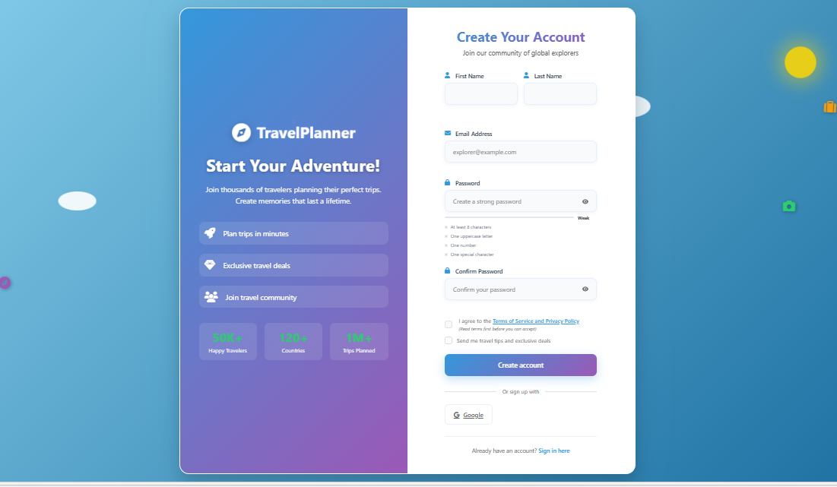

1 Marketing Sidebar (Left Pane)

* Branding: Displays the "TravelPlanner" logo and a catchy "Start Your Adventure!" headline.
* Value Propositions: Lists three key benefits: "Plan trips in minutes," "Exclusive travel deals," and "Join travel community".
* Social Proof Metrics: Features three statistics: "50K+ Happy Travelers," "120+ Countries," and "1M+ Trips Planned".

2 User Registration Form (Right Pane)

* Header: Features the title "Create Your Account" and the sub-header "Join our community of global explorers".
* Personal Information: Includes side-by-side input fields for "First Name" and "Last Name".
* Contact Details: A full-width field for "Email Address" with an example placeholder.
* Credential Setup: Includes "Password" and "Confirm Password" fields with visibility toggle icons.
* Security Feedback: Features a real-time password strength meter and a four-point validation checklist (characters, uppercase, number, special character).

3 Legal and Submission

* Checkboxes: Includes mandatory agreement to "Terms of Service and Privacy Policy" and an optional newsletter subscription.
* Primary Action: A gradient "Create account" button.
* Social Sign-on: Provides an "Or sign up with" option featuring a Google authentication button.
* Navigation: Includes a "Sign in here" link for users who already have an account.

**4.2.2 – Login Page:**

The Login Page serves as the primary gateway for returning users to access their travel plans and saved data.

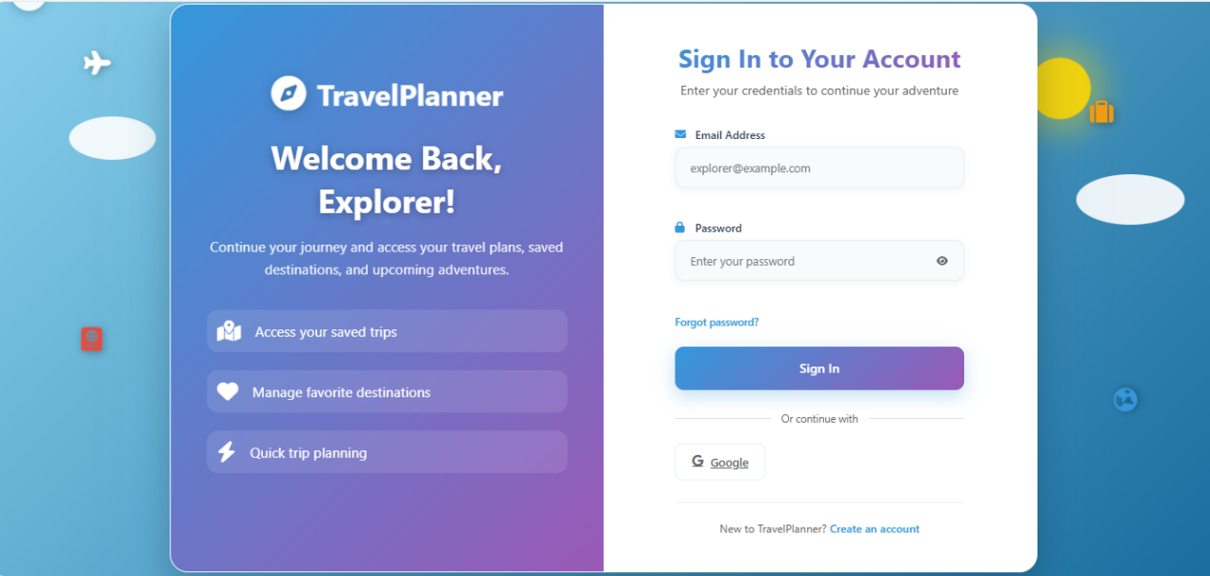

**1 Marketing & Branding Sidebar**

* Features the "TravelPlanner" logo and a "Welcome Back, Explorer!" headline.
* Lists core user benefits: "Access your saved trips," "Manage favorite destinations," and "Quick trip planning".

**2 Authentication Form**

* Includes standard input fields for "Email Address" and "Password".
* Features a "Forgot password?" recovery link and a "Sign In" button with a purple-to-blue gradient.

**3 Alternative Entry Points**

* Provides a Google social login option ("Or continue with Google").
* Includes a footer link, "Create an account," for new users.

**4.2.3 – Home Page:**

The Home Page is the main entry point of the Travel Planner Website. It provides users with a clear overview of the platform and easy access to its core features. From the home page, users can quickly navigate to plan new trips, view existing trips, and explore the services offered by the website.

The design of the home page focuses on simplicity and usability, with a clean layout and intuitive navigation. Key actions such as signing in, registering, and accessing trip planning tools are prominently displayed to enhance the user experience. This ensures that both new and returning users can interact with the system efficiently from the first visit.

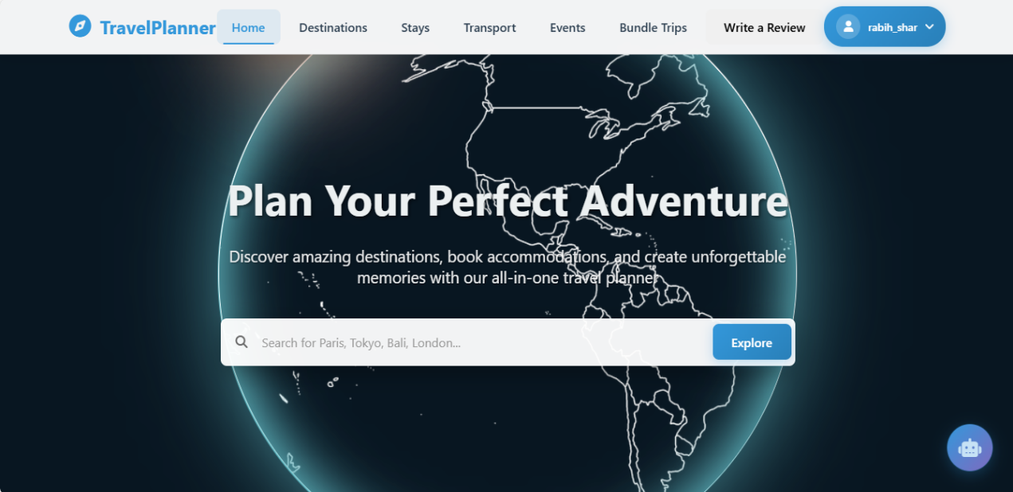

**1.** **Navigation Bar (Header)**

* Displays the website logo and name **TravelPlanner** on the left.
* Provides main navigation links: **Home, Destinations, Stays, Transport, Events, Bundle Trips**.
* Includes a **Write a Review** button for user interaction.
* Shows the logged-in user profile section with the username, allowing access to account options.

**2.** **Hero Section (Main Banner)**

* Features a visually engaging background with a world map/globe design to represent global travel.
* Immediately captures the user’s attention and reflects the purpose of the website.

**3.** **Main Title (Call to Action)**

* Displays the heading **“Plan Your Perfect Adventure”**.
* Clearly communicates the goal of the platform: helping users plan their trips easily.

**4.** **Subtitle / Description Text**

* Provides a brief explanation of the platform’s functionality.
* Highlights key features such as discovering destinations, booking accommodations, and creating memorable travel experiences.

**5.**  **Search Bar**

* Allows users to search for destinations directly from the home page.
* Includes placeholder text with example locations (e.g., Paris, Tokyo, Bali, London) to guide users.

**6.** **Explore Button**

* Positioned next to the search bar for quick action.
* Enables users to start exploring destinations based on their search input.

**7.** **Chat Bot Button**

* When click it a small popup appears on the right-side of the screen and you can talk to the chatbot ask him about everything you need to know about this website.

**8.** **User Experience Design**

* Clean and modern layout for easy navigation.
* Large text and clear buttons improve accessibility and usability.
* Responsive design ensures proper display across different devices.

**9.** **Quick Access Functionality**

* Home page acts as a central hub, allowing users to quickly access all major sections of the website.
* Encourages user engagement by simplifying the trip planning process from the first visit.

**10.** **Popular Destinations**

* User can view all destinations.
* Shows the most popular destinations that the people usually go to and the user can explore this destinations and see the details about every destination.

**11.** **How Travel Planner Works**

* This shows the user how to book from a complete trip.
* 1. To choose a destination to go to.
* 2. Book accommodation to stay in.
* 3. Arrange Transport.
* 4. Add Activities.

**12.** **What Travelers Say**

* This shows the reviews the users make about trips, destinations, accommodations, flights, bundles.

**13.** **Footer Section**

* Quick links to (destinations, accommodations, transport, events).
* Support (help center, contact us, FAQ).

**4.2.4 – Destinations Page:**

The Destinations page allows users to explore and discover travel destinations from around the world. It provides search, filtering, and sorting features to help users easily find destinations, view ratings and details, and select accommodations as part of their trip planning process.

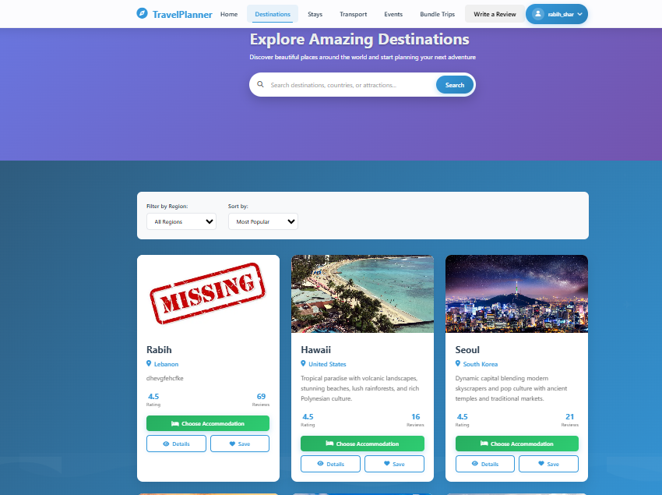

**1.** Page Title Section (Hero Area)

* Displays the main heading “Explore Amazing Destinations”.
* Includes a short descriptive subtitle encouraging users to discover and plan trips.
* Uses a visually appealing gradient background to highlight the section.

**2.** Search Bar

* Allows users to search for destinations, countries, or attractions.
* Positioned prominently to enable quick access to destination exploration.
* Includes a Search button to execute the query.

**3.** Filter and Sorting Controls

* Filter by Region dropdown allows users to narrow destinations by geographic area.
* Sort by dropdown enables sorting options such as Most Popular.
* Improves usability by helping users find relevant destinations efficiently.

**4.** Destination Cards Section

* Displays destinations in a card-based layout for easy browsing.
* Each card includes:
  + Destination image
  + Destination name
  + Country or region information
  + Short descriptive text about the destination

**5.** Ratings and Reviews

* Each destination shows a star rating (e.g., 4.5).
* Displays the total number of user reviews, enhancing trust and credibility.

**6.** Action Buttons on Cards

* Choose Accommodation button allows users to proceed with booking options.
* Details button provides more information about the destination.
* Save button lets users save destinations for future planning.

**7.** Visual Design and Layout

* Uses consistent colors and spacing for a clean and modern interface.
* Card layout ensures readability and responsiveness across different screen sizes.

**8.** User Experience

* Designed to make destination discovery intuitive and fast.
* Combines search, filtering, and visual browsing to support efficient trip planning.

**4.2.5 – Accommodation Page:**

The Stays page allows users to search and book accommodations for their trips. It provides various filtering options to help users find hotels, resorts, and other lodging types based on their preferences.

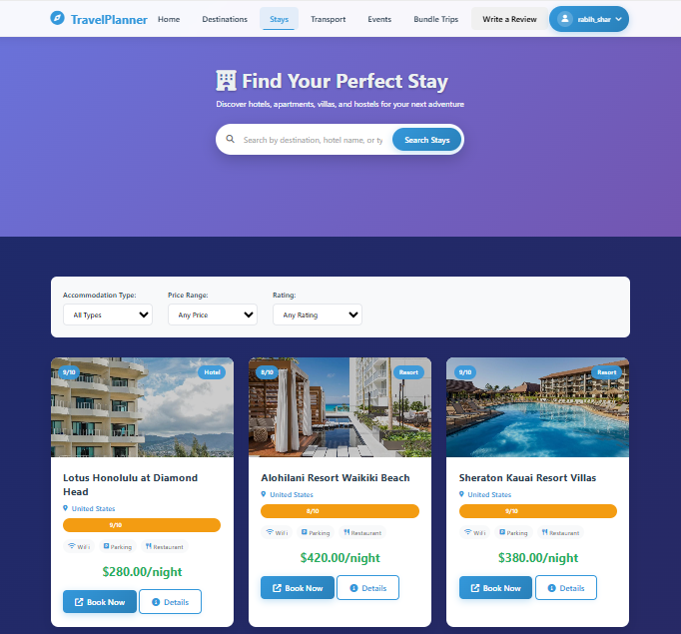

1. **Page Title Section**

* Displays the heading **“Find Your Perfect Stay”**.
* Includes a short description explaining accommodation options such as hotels, apartments, villas, and hostels.

2. **Search Bar**

* Allows users to search by destination or accommodation name.
* Includes a **Search Stays** button for quick results.

3. **Filter Options**

* **Accommodation Type** filter to select lodging categories.
* **Price Range** filter to match the user’s budget.
* **Rating** filter to view accommodations based on user ratings.

4. **Accommodation Cards**

* Displays accommodation options in a card layout.
* Each card includes:
  + Accommodation image
  + Name and location
  + Rating score
  + Available facilities (Wi-Fi, parking, restaurant, etc.)

5. **Pricing Information**

* Shows the price per night clearly for each accommodation.

6. **Action Buttons**

* **Book Now** button to start the booking process.
* **Details** button to view more information about the accommodation.

7. **User Experience and Design**

* Clean, modern layout with consistent colors.
* Responsive design ensures usability on different screen sizes.

**4.2.6 – Transport Page:**

The Transport page is a flight search and booking interface that allows users to enter their travel details, select passenger information and travel class, and search for available flights. The page is designed to be simple, user-friendly, and efficient, enabling users to compare flight options and proceed with booking based on their preferences.

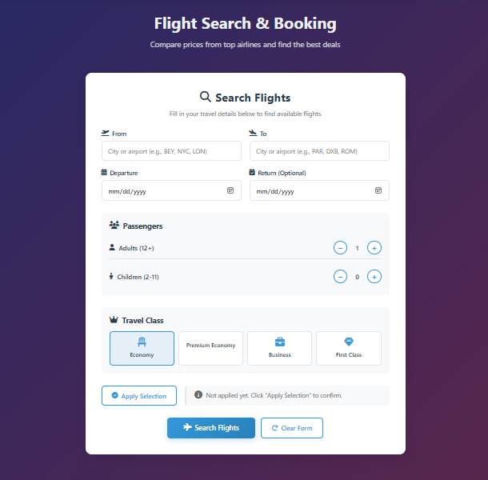

1. **Page Header**

* Displays the title **“Flight Search & Booking”**.
* Includes a short subtitle explaining the purpose of the page: comparing prices from top airlines and finding the best deals.

2. **From Field**

* Input field where the user enters the departure city or airport.
* Accepts city names or airport codes (e.g., BEY, NYC, LON).

3. **To Field**

* Input field for the destination city or airport.
* Works similarly to the “From” field and defines where the user wants to travel.

4. **Departure Date**

* Date picker input for selecting the outbound flight date.
* Ensures users specify when they plan to start their journey.

5. **Return Date (Optional)**

* Optional date picker for round-trip flights.
* If left empty, the system can treat the search as a one-way trip.

6. **Passengers Section**

* Allows users to specify the number of travelers.
* **Adults (12+)**: Increase or decrease the number of adult passengers using plus and minus buttons.
* **Children (2–11)**: Separate counter for child passengers.

7. **Travel Class Selection**

* Users can choose the preferred travel class:
  + Economy
  + Premium Economy
  + Business
  + First Class
* The selected class is visually highlighted.

8. **Apply Selection Button**

* Confirms the selected passenger count and travel class.
* Prevents accidental changes before proceeding.

9. **Search Flights Button**

* Main action button that submits all entered data.
* Initiates the flight search based on user inputs.

10. **Clear Form Button**

* Resets all fields to their default values.
* Allows users to start a new search easily.

**4.2.7 – Events Page:**

The Events page allows users to browse and discover tickets for popular events such as sports, motorsports, combat sports, and live concerts. It presents visually rich event cards to help users quickly identify their favorite events and proceed with ticket selection.

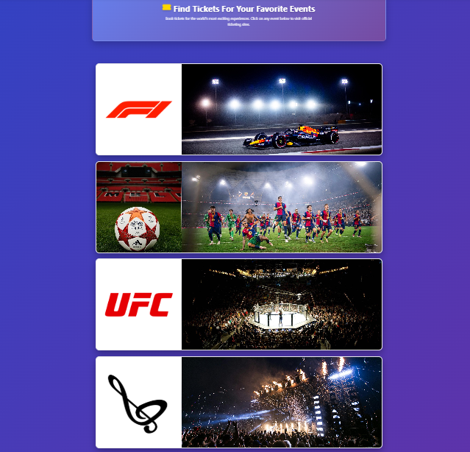

**1. Page Header**

* Displays the title **“Find Tickets For Your Favorite Events”**
* Includes a short subtitle encouraging users to explore and book live events

**2. Event Cards Layout**

* Events are displayed in a vertical list of large cards
* Each card represents a different event category using images and logos

**3. Formula 1 (F1) Event Card**

* Displays the official Formula 1 logo
* Shows a Formula 1 race car image
* Represents motorsport and Grand Prix racing events

**4. Football (Soccer) Event Card**

* Displays a football stadium and players
* Represents football matches and tournaments
* Targets users interested in football events

**5. UFC Event Card**

* Displays the official UFC logo
* Shows a crowded UFC arena
* Represents mixed martial arts (MMA) events

**6. Music & Concerts Event Card**

* Displays a live concert crowd and stage lighting
* Represents music concerts and live performances

**7. Visual Design**

* Uses large images for better user engagement
* Logos help users quickly recognize event categories

**8. User Interaction**

* Each event card is clickable
* Clicking a card redirects the user to ticket details

**9. Consistent Styling**

* All event cards have a uniform layout
* The design matches the overall website theme

**4.2.8 – Bundle Trips Page:**

The Bundle Trips page allows users to explore curated travel packages around the world. Users can search for destinations, filter trips by region, and view detailed information about each package before booking.

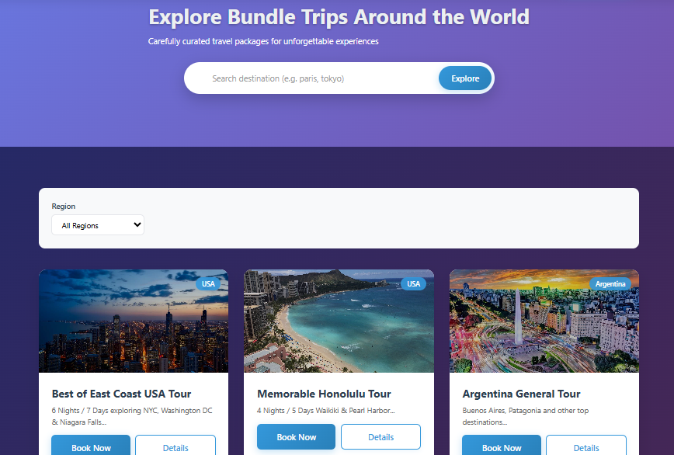

**1. Page Header**

* Displays the title **“Explore Bundle Trips Around the World”**
* Includes a subtitle describing curated travel packages for unforgettable experiences

**2. Search Bar**

* Allows users to search for trips by destination name
* Provides example placeholder text to guide user input
* Includes an **Explore** button to start the search

**3. Region Filter**

* Dropdown menu that allows users to filter trips by region
* Default option shows **All Regions**
* Helps users narrow down available travel packages

**4. Travel Package Cards**

* Displays available bundle trips in a card-based layout
* Each card contains an image representing the destination
* Shows the trip title and a short description

**5. Trip Duration Information**

* Displays the number of nights and days for each package
* Helps users quickly understand trip length

**6. Country / Region Tag**

* Each card includes a small label indicating the country or region (e.g., USA, Argentina)
* Improves clarity and quick identification of destinations

**7. Action Buttons**

* **Book Now** button allows users to proceed with booking
* **Details** button displays more information about the selected trip

**8. Visual Design**

* Uses high-quality destination images to attract users
* Consistent card design improves readability and user experience

**9. User Interaction Flow**

* Users search or filter trips
* Browse available packages
* View details or proceed directly to booking

**4.2.9 – Write a Review Page:**

A small popup opens on the screen, inviting you to share your experience. It asks for a quick rating and a short review, making it easy to give feedback in just a few seconds.

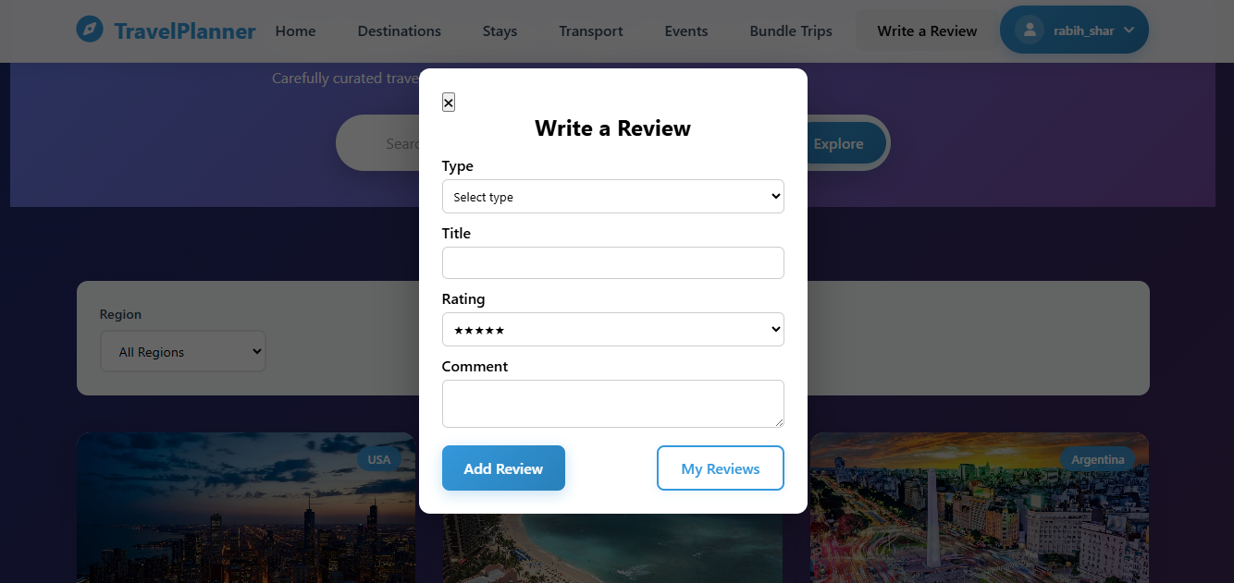

**1. Type options**

* User can select the type (destination, trip, stay, event. bundle) he wants to review.

**2. Title**

* User should type the title of what he is writing about.

**3. Rating**

* User should select a rating from 1 to 5 stars.

**4. Comment**

* This is where the user should write his review.

**5. Add Review Button**

* After the user write his review he should press add review so the review is saved.

**6. My Reviews Button**

* User can view his reviews by clicking on it.

**4.2.10 – Profile Page:**

This page is a user profile dashboard that displays personal information, travel activity, and quick actions. It provides an overview of the user’s journey, reviews, destinations, and account settings in a clean and organized layout.

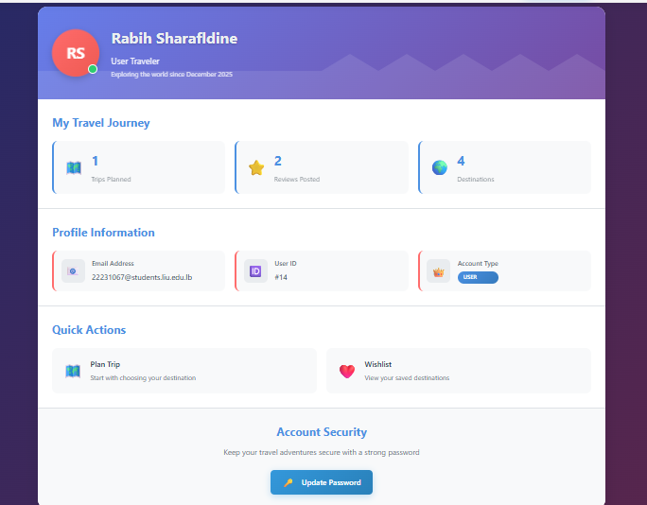

**1. Profile Header**

* Displays the user’s name and avatar
* Shows the user role (User Traveler)
* Indicates activity status
* Includes a short tagline about exploring the world

**2. My Travel Journey Section**

* Shows key statistics in card format
* Displays the number of trips planned
* Shows how many reviews were posted
* Lists the number of destinations visited

**3. Profile Information**

* Displays the user’s email address
* Shows the unique user ID
* Indicates the account type (User)

**4. Quick Actions**

* Provides shortcuts to common actions
* Includes an option to plan a new trip
* Includes access to the wishlist of saved destinations

**5. Account Security**

* Focuses on user account protection
* Encourages keeping the account secure
* Provides an option to update the password

**4.2.11 – Destination Details Page:**

This page presents a destination details section highlighting must-see places in Hawaii. It showcases popular attractions with images, brief descriptions, entry fees, visiting hours, and best visiting times, helping users plan their trip easily. 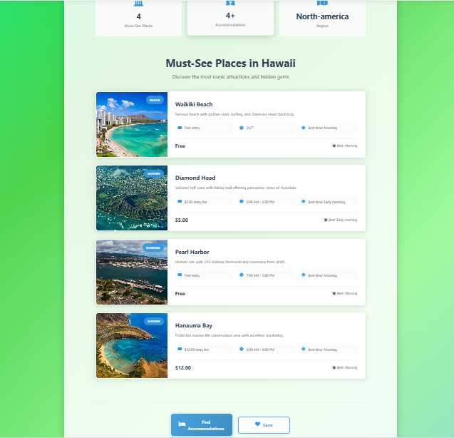

**1. Destination Overview**

* Displays the destination region (North America)
* Shows summary statistics such as must-see places and accommodations
* Introduces the destination content clearly

**2. Must-See Places Section**

* Title highlights featured attractions in Hawaii
* Includes a short subtitle encouraging exploration
* Organizes attractions in a vertical list

**3. Attraction Cards**

* Each card represents a single place
* Includes a high-quality image preview
* Displays the attraction name
* Shows a short description of the place

**4. Visit Details**

* Displays entry fee (Free or paid)
* Shows recommended visiting hours
* Indicates the best time to visit (e.g., morning, early morning)

**5. Individual Attractions**

* Waikiki Beach: Popular beach with city views and Diamond Head backdrop
* Diamond Head: Volcanic crater with panoramic views
* Pearl Harbor: Historic site with museums and memorials
* Hanauma Bay: Marine conservation area ideal for snorkeling

**6. Action Buttons**

* “Find Accommodations” button to search nearby stays
* “Save” button to add the destination to the wishlist

**4.2.12 – Bundle Trip Details Page:**

This page displays detailed information about a travel package, highlighting the destination, trip duration, included services, and ideal audience, with a strong visual focus and a clear booking call-to-action.

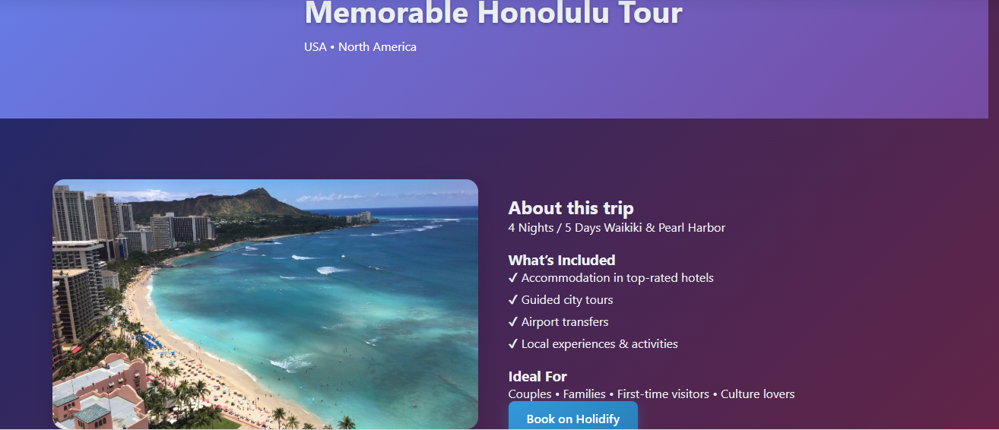

**1. Trip Header**

* Displays the trip title (Memorable Honolulu Tour)
* Shows the country and region (USA · North America)
* Uses a large banner to create a strong first impression

**2. Hero Image Section**

* Features a large, high-quality image of the destination
* Visually represents the main location (Waikiki Beach)
* Enhances user engagement and appeal

**3. About This Trip**

* Provides a short summary of the travel package
* Displays trip duration (4 Nights / 5 Days)
* Highlights key locations included in the itinerary

**4. What’s Included**

* Lists services included in the package
* Accommodation in top-rated hotels
* Guided city tours
* Airport transfers
* Local experiences and activities

**5. Ideal For Section**

* Identifies the target audience for the trip
* Couples
* Families
* First-time visitors
* Culture lovers

**6. Call-to-Action**

* Displays a prominent “Book on Holidify” button
* Encourages users to proceed with booking
* Clearly indicates the next user action

**4.2.13 – Trip Details Card Page:**The Trip Details Card is a clean, organized UI component used to display a summary of a user's flight booking. Each card includes essential booking information in a structured layout: the route (origin → destination), passenger details (adults and children), travel class, creation timestamp, and booking status. Action buttons such as "Cancel Trip" and "Remove from Page" are placed at the bottom, allowing users to manage their trips easily. The design uses clear typography, consistent spacing, and a card-based format to enhance readability and user interaction within a trip management dashboard.

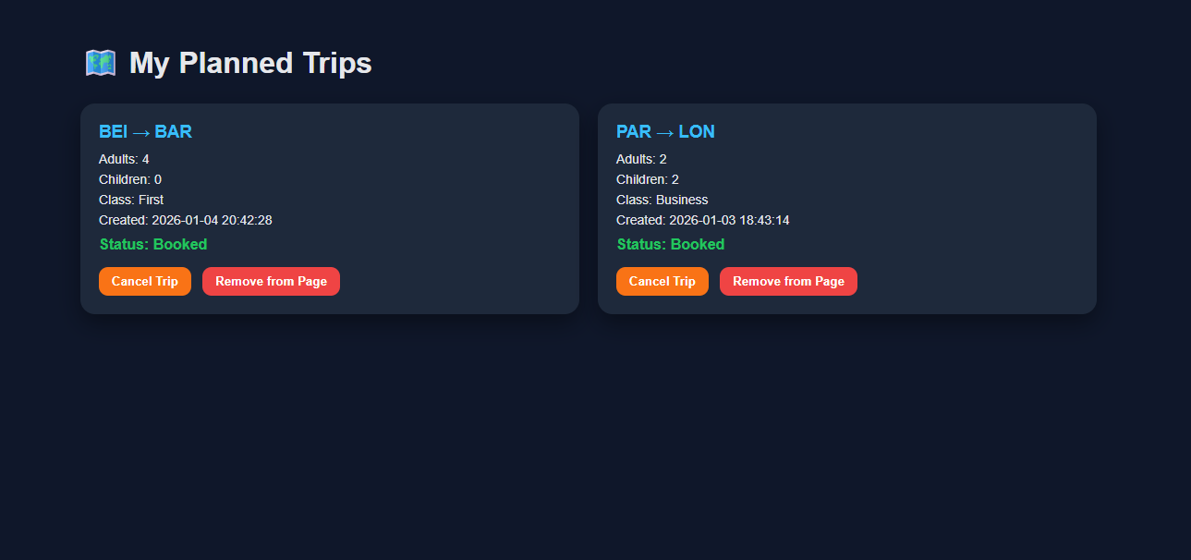

1. **Page Title**
   * “My Planned Trips” is clearly displayed at the top, indicating this is a user’s trip management dashboard.
2. **Trip Card 1**
   * Route: BEI → BAR (likely Beijing to Barcelona)
   * Passengers: 4 Adults, 0 Children
   * Class: First
   * Created: 2026-01-04 20:42:28
   * Status: Booked
   * Buttons: “Cancel Trip” and “Remove from Page” are available as actions.
3. **Trip Card 2**
   * Route: PAR → LON (Paris to London)
   * Passengers: 2 Adults, 2 Children
   * Class: Business
   * Created: 2026-01-03 18:43:14
   * Status: Booked
   * Buttons: “Cancel Trip” and “Remove from Page” are available as actions.
4. **Layout & Design**
   * Each trip is presented in a separate card for clear visual separation.
   * Key details are listed in a simple label-value format.
   * Action buttons are placed at the bottom of each card for user interaction.
5. **User Actions**
   * Cancel Trip: Likely cancels the booking (may involve refund/penalty).
   * Remove from Page: Probably removes the trip from the view without canceling the booking (archive/hide functionality).
6. **Visual & UX Notes**
   * Clean, minimal design with clear typography.
   * Status (“Booked”) is prominently displayed for quick scanning.
   * Buttons are discrete but accessible, with “Cancel Trip” appearing before “Remove from Page” (likely because cancellation is a more significant action).

**4.2.14 – Wishlist Page:**

This image shows a Wishlist page interface in a travel or booking application. It is designed to help users save and organize destinations they are interested in visiting in the future.

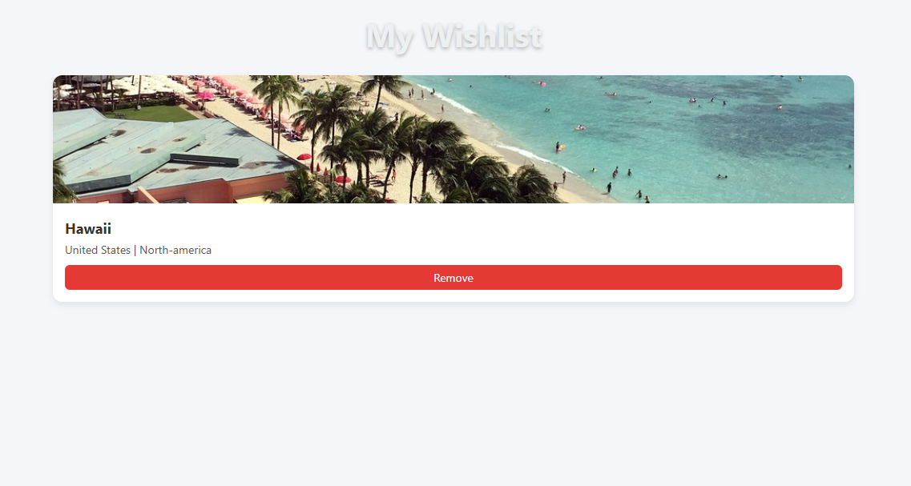

**1** **Page Header**

* Displays the title "My Wishlist" at the top of the interface.
* Uses a light grey, semi-transparent font style to keep the focus on the content cards below.

**2** **Destination Hero Image**

* A wide-aspect ratio banner featuring a high-resolution photo of the destination (e.g., Hawaii beach scene).
* Visuals are designed to evoke an emotional connection to the travel location.

**3** **Destination Information**

* **Primary Title:** Displays the specific destination name ("Hawaii") in bold, dark typography.
* **Location Metadata:** Lists the country and continent ("United States | North-america") in a smaller, lighter font to provide geographical context.

**4** **Action Button**

* A prominent, full-width red button labeled "Remove."
* Provides a clear call-to-action (CTA) for the user to delete the item from their list.
* The high-contrast color ensures the destructive action is easily identifiable.

**5** **Card Container**

* Utilizes a white background with rounded corners for a modern look.
* Includes a subtle drop shadow (elevation) to separate the card from the background, creating a sense of depth in the UI.

**4.2.15 – Update Password Page:**

The Update Password page is a secure form designed to allow users to reset their existing password. It features real-time validation feedback through a "Password Strength" indicator and a checklist of security requirements to ensure account integrity.

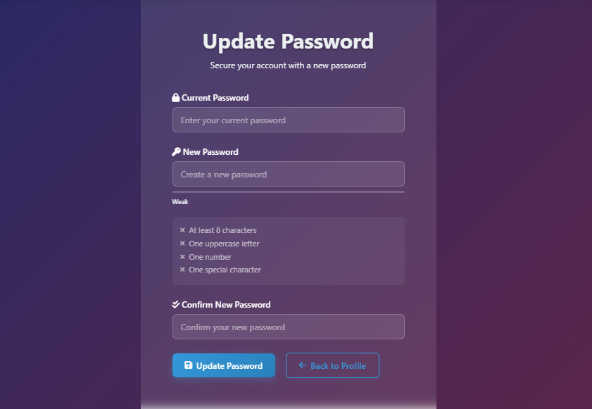

**1** **Page Header and Subtext**

* Displays the primary title "Update Password" in a bold, white sans-serif font.
* Includes a descriptive sub-headline: "Secure your account with a new password" to guide the user's intent.

**2** **Current Password Input**

* Features a field label preceded by a padlock icon.
* Contains a placeholder text "Enter your current password" to verify the user's identity before the change.

**3** **New Password Input and Strength Meter**

* Features a field label preceded by a key icon.
* Includes a "Weak" strength indicator bar located directly beneath the input field to provide immediate visual feedback on password complexity.

**4** **Password Requirement Checklist**

* A dedicated box listing four specific security criteria:
  + At least 8 characters.
  + One uppercase letter.
  + One number.
  + One special character.
* Each item is prefixed with an "X" icon, which likely updates to a checkmark as the user meets each requirement.

**5** **Confirm New Password Input**

* Features a field label preceded by a double-check icon.
* Provides a placeholder text "Confirm your new password" to prevent typos by requiring matching inputs.

**6** **Action Buttons**

* **Update Password:** A primary blue button with a save icon used to submit the form.
* **Back to Profile:** A secondary outlined button with a back arrow, allowing users to cancel the action and return to their settings.

**4.2.16 – Chat Bot Page:**

The Travel Assistant is an integrated AI chatbot designed to provide real-time concierge services, ranging from flight and hotel inquiries to general travel tips.

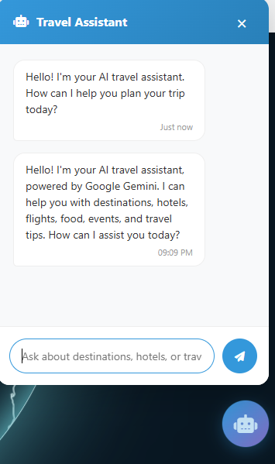

**1** **Chatbot Header**

* Displays the title "Travel Assistant" accompanied by a robot icon.
* The header uses a solid blue background with a white "X" close button in the top right corner to dismiss the window.

**2** **Message Thread**

* **AI Welcome Message:** Displays introductory text: "Hello! I'm your AI travel assistant, powered by Google Gemini."
* **Service Scope:** Explicitly lists capabilities such as help with destinations, hotels, flights, food, events, and travel tips.
* **Timestamps:** Each message bubble includes a timestamp (e.g., "Just now" or "09:09 PM") for context.

**3** **Input Field**

* A rounded text box with the placeholder: "Ask about destinations, hotels, or trav...".
* Allows users to type natural language queries.

**4** **Send Action**

* A circular blue button with a paper plane icon located to the right of the input field to trigger the message sending process.

**5** **Floating Action Button (FAB)**

* A persistent circular icon with a robot face located in the bottom right corner of the screen to open or minimize the chat interface.

**4.2.17 – Admin Page:**

The Admin Dashboard serves as the central control hub for platform administrators. It provides a high-level overview of system metrics (users, trips, destinations) and offers quick access to management tools for platform data and user accounts.

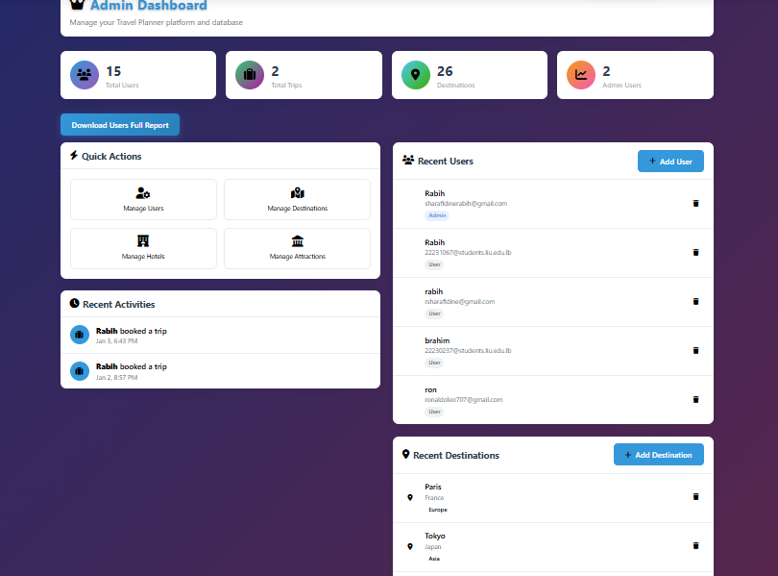

**1** **Dashboard Header and Global Report**

* **Title:** Displays "Admin Dashboard" with a subtitle "Manage your Travel Planner platform and database."
* **Global Action:** Includes a "Download Users Full Report" button to export comprehensive platform data.

**2** **Key Performance Indicators (KPI) Cards**

* A horizontal row of four metric cards providing real-time statistics:
  + **Total Users:** Displays count (15) with a group icon.
  + **Total Trips:** Displays count (2) with a suitcase icon.
  + **Destinations:** Displays count (26) with a map pin icon.
  + **Admin Users:** Displays count (2) with a line graph icon.

**3** **Quick Actions Grid**

* A quadrant of navigation buttons for rapid database management:
  + **Manage Users:** Direct access to account controls.
  + **Manage Destinations:** Tools to add/edit travel locations.
  + **Manage Hotels:** Interface for accommodation listings.
  + **Manage Attractions:** Controls for local points of interest.

**4** **Recent Activities Log**

* A chronological feed showing latest platform events.
* Each entry includes the user's name, the action performed (e.g., "booked a trip"), and a specific date/time stamp.

**5** **User and Destination Management Lists**

* **Recent Users:** A vertical list showing user names, email addresses, and role tags (Admin vs. User). Includes an "+ Add User" button and individual delete (trash) icons.
* **Recent Destinations:** A vertical list showing destination names (e.g., Paris, Tokyo), countries, and continents. Includes an "+ Add Destination" button and individual delete icons.

**5 - Conclusion**

The Travel Planner System was designed and developed to simplify and enhance the travel planning experience by integrating all essential travel services into a single, unified platform. Throughout this project, we addressed the common challenges faced by travelers, such as relying on multiple platforms, lack of coordination between bookings, and limited flexibility when planning trips. By offering both custom trip planning and ready-made bundle packages, the system provides users with greater control, convenience, and cost efficiency.

The system successfully implements core functionalities including user management, destination exploration, accommodation booking, flight search, event booking, transportation arrangement, budget tracking, and review management. The use of a structured three-tier architecture (presentation layer, application logic, and database layer) ensures that the system is scalable, maintainable, and reliable. Security measures such as encrypted passwords, role-based access control, and protected data handling further strengthen the platform’s integrity.

Additionally, the database design and ERD structure effectively support complex relationships between users, trips, destinations, and services, allowing accurate data management and seamless system operations. Overall, the Travel Planner System meets its objectives by providing an intuitive, flexible, and efficient solution that improves the travel planning process for users while offering administrators powerful tools for platform management.

**6 - Final Work and Future Enhancements:**

The current implementation of the Travel Planner System delivers a complete and functional travel planning solution. However, there are several enhancements that can be considered for future development to further improve the system’s functionality and user experience:

1. **Real-Time Flight and Booking APIs**  
   Integrating real-time airline and hotel APIs would enable live pricing, seat availability, and instant confirmations.
2. **Travel Insurance and Visa Services**  
   Adding optional travel insurance and visa guidance services would make the platform more comprehensive.
3. **AI-Based Recommendations**  
   Enhancing the recommendation system using machine learning could provide smarter suggestions based on user behavior, budget, and travel history.
4. **Multi-Currency and Localization Support**  
   Supporting multiple currencies and languages would allow the system to serve international users more effectively.
5. **Offline Trip Access**  
   Allowing users to access saved itineraries offline would improve usability during travel.
6. **Advanced Analytics for Admins**  
   Providing detailed analytics dashboards for bookings, revenue, and user activity would help administrators make data-driven decisions.
7. **Integration with Maps and Navigation Services**  
   Linking destinations and activities with map services would help users visualize routes and nearby attractions.

In conclusion, the Travel Planner System lays a strong foundation for a modern, all-in-one travel management platform. With the proposed enhancements, the system can evolve into a fully intelligent, globally scalable travel solution that delivers even greater value to both users and administrators.